**A project to explore the major regions, localities (Neighbourhood) & cities within the state of New South Wales Australia.**

**Data Section**

To assist Aus-Migration Pty I would be leveraging 3 Data Sources or types:

1. A raw data file from Australia Post with an up-to-date downloadable database of Australian Postcodes and Localities, including accurate longitude and latitude values. This data set is in a CSV format filtered to New South Wales. The description of each field is as below:

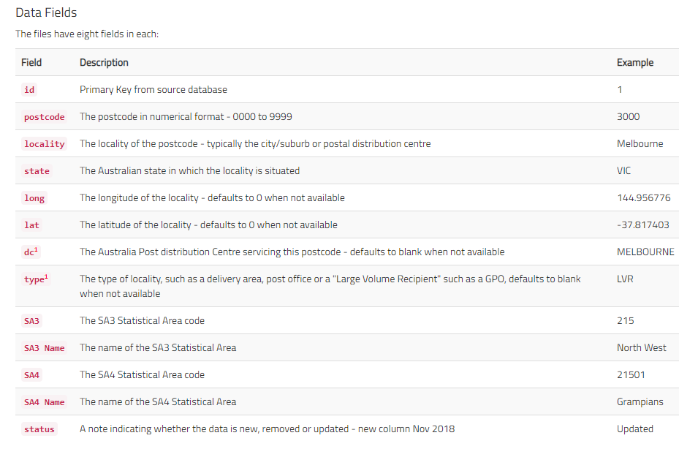

1. Australia Bureau of Statistics (ABS) provides the digital boundary file as shape file which would be used for making some of the maps in addition to that from Foursquare. The ABS also provided the population distribution data with description of the examples shown below.

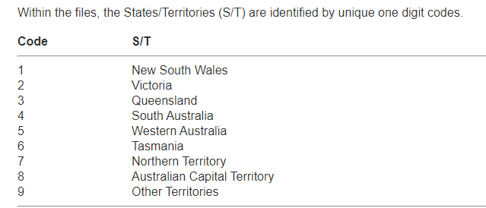

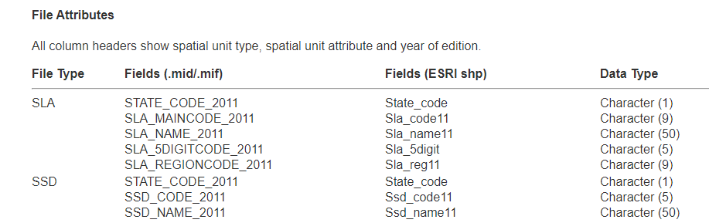

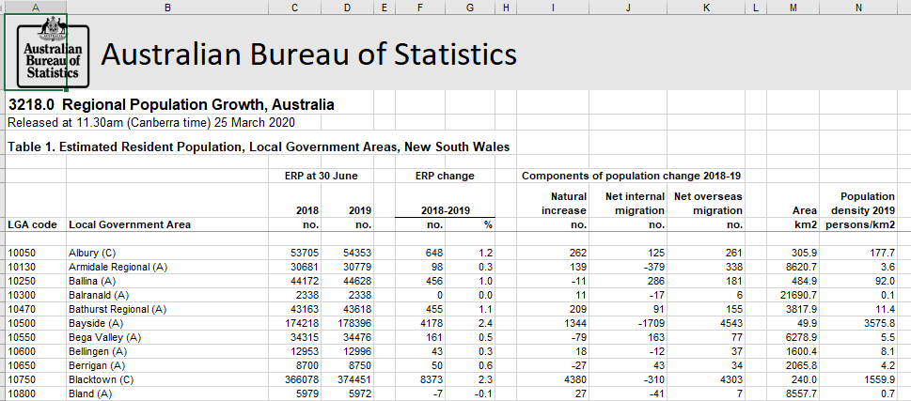

1. Foursquare location data. I will be using the Foursquare API. With the Foursquare API. I would first construct a URL to send a request to the API to search for a specific type of venues. I then search for specific type of venues around a given location eg. Sydney or Illawara. We can also learn more about a specific venue or store or shop, like their full address, their working hours, and their menu if they have one, and so on. Furthermore, we can explore a given location by finding what popular spots exist in the vicinity of the location, and for this data a regular call to the API would be made. I will make the call to the database and get a JSON file of the trending venues that are nearby. In the JSON file, for each trending venue, we get mostly its name, unique ID, location, and category. From the JSON file I will then extract the categories for a Dataframe. See sample JSON output and dataframe below:

{'meta': {'code': 200, 'requestId': '5e91415f542890001b018226'},

'response': {'suggestedFilters': {'header': 'Tap to show:',

'filters': [{'name': 'Open now', 'key': 'openNow'}]},

'headerLocation': 'Sydney',

'headerFullLocation': 'Sydney',

'headerLocationGranularity': 'city',

'totalResults': 128,

'suggestedBounds': {'ne': {'lat': -33.97070495499995,

'lng': 151.11638853595687},

'sw': {'lat': -34.06070504500004, 'lng': 151.0080114640431}},

'groups': [{'type': 'Recommended Places',

'name': 'recommended',

'items': [{'reasons': {'count': 0,

'items': [{'summary': 'This spot is popular',

'type': 'general',

'reasonName': 'globalInteractionReason'}]},

'venue': {'id': '4dafa82e4b22d9b3bcc7031b',

'name': 'Smiley Thai',

'location': {'address': '560 Box Rd',

'lat': -34.016321853913176,

'lng': 151.06603632638232,

'labeledLatLngs': [{'label': 'display',

'lat': -34.016321853913176,

'lng': 151.06603632638232}],

'distance': 360,

'postalCode': '2226',

'cc': 'AU',

'city': 'Jannali',

'state': 'NSW',

'country': 'Australia',

'formattedAddress': ['560 Box Rd', 'Jannali NSW 2226', 'Australia']},

'categories': [{'id': '4bf58dd8d48988d149941735',

'name': 'Thai Restaurant',

'pluralName': 'Thai Restaurants',

'shortName': 'Thai',

'icon': {'prefix': 'https://ss3.4sqi.net/img/categories_v2/food/thai_',

'suffix': '.png'},

'primary': True}],

'photos': {'count': 0, 'groups': []}},

'referralId': 'e-0-4dafa82e4b22d9b3bcc7031b-0'},

{'reasons': {'count': 0,

'items': [{'summary': 'This spot is popular',

'type': 'general',

'reasonName': 'globalInteractionReason'}]},

